Capstone Project 3: Milestone Report II

As per Milestone Report I, we have performed a initial analysis on the data and explored it as well

Now, we will classify the tweets into positive or negative using a neural network model.

Before that we have to preprocess the data

* Stemming
* Removing unwanted characters through regex
* Stop Words removal

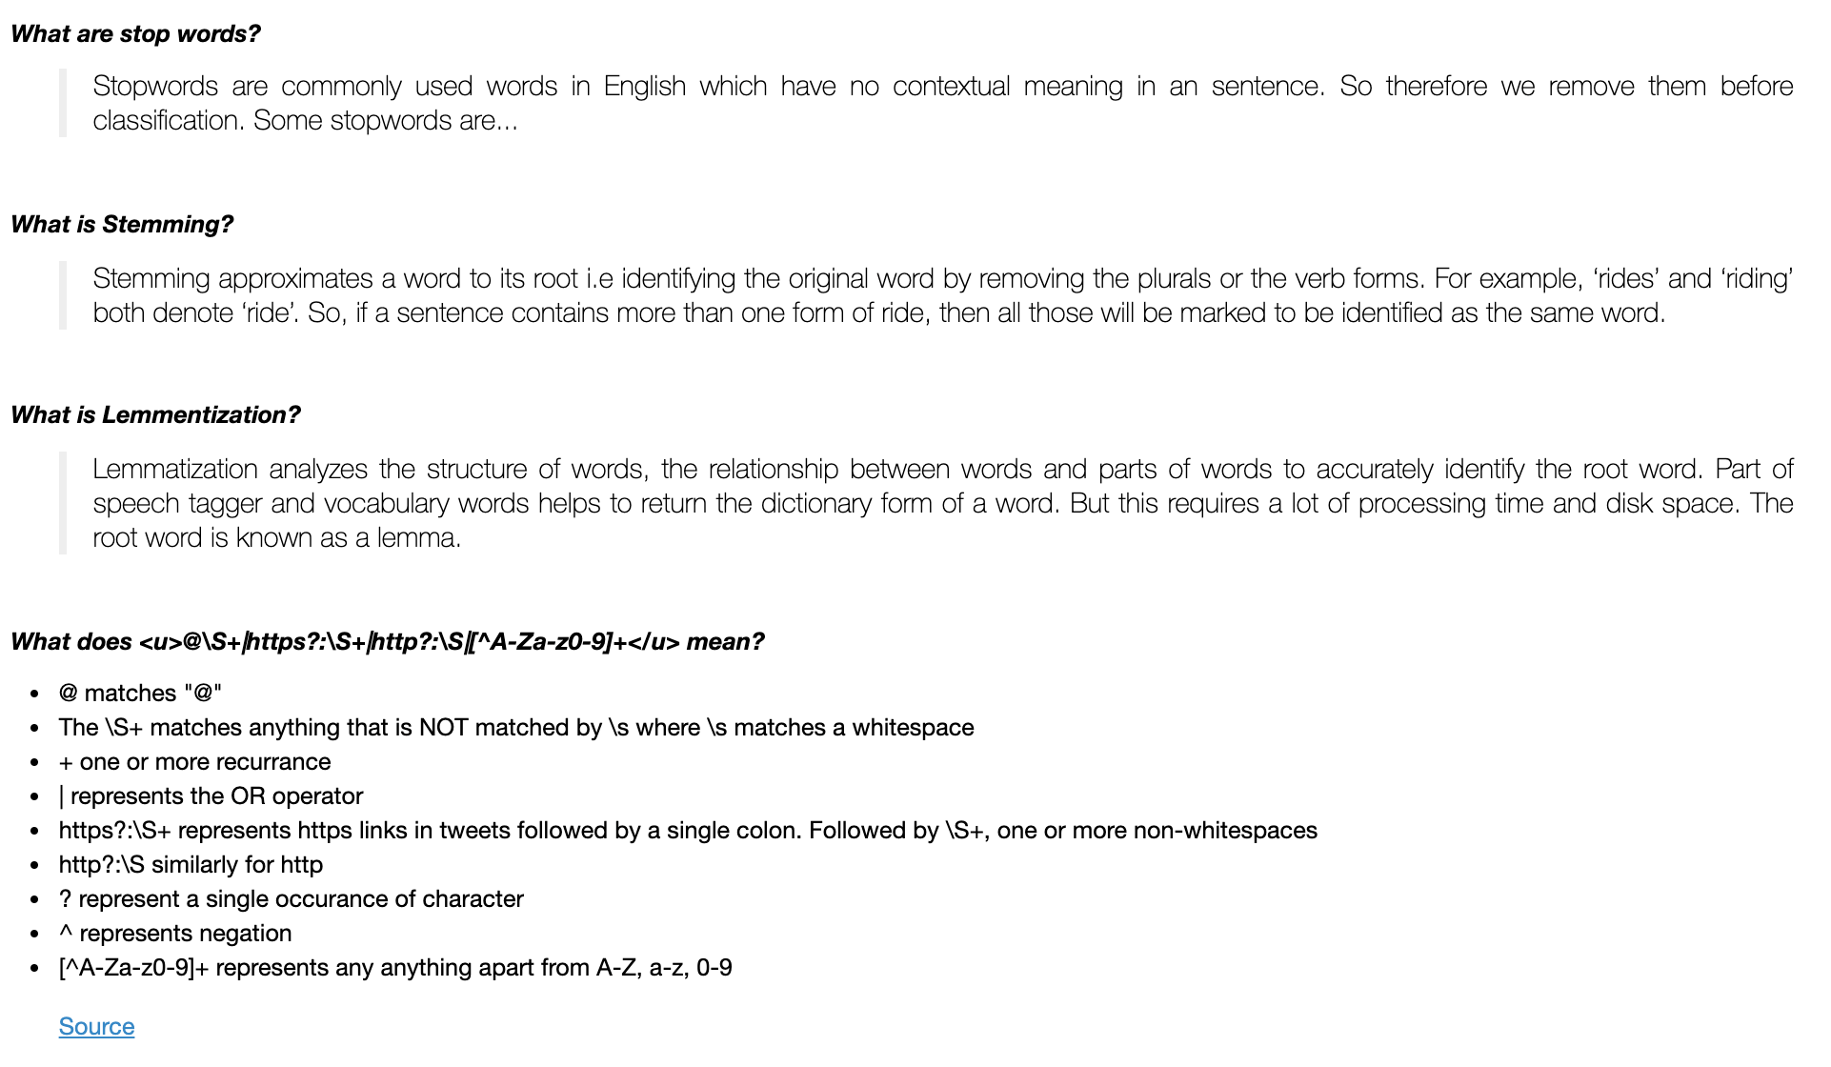

Once the above steps are completed, we can visualize the positive and negative tweets using word cloud.

Positive Word Cloud

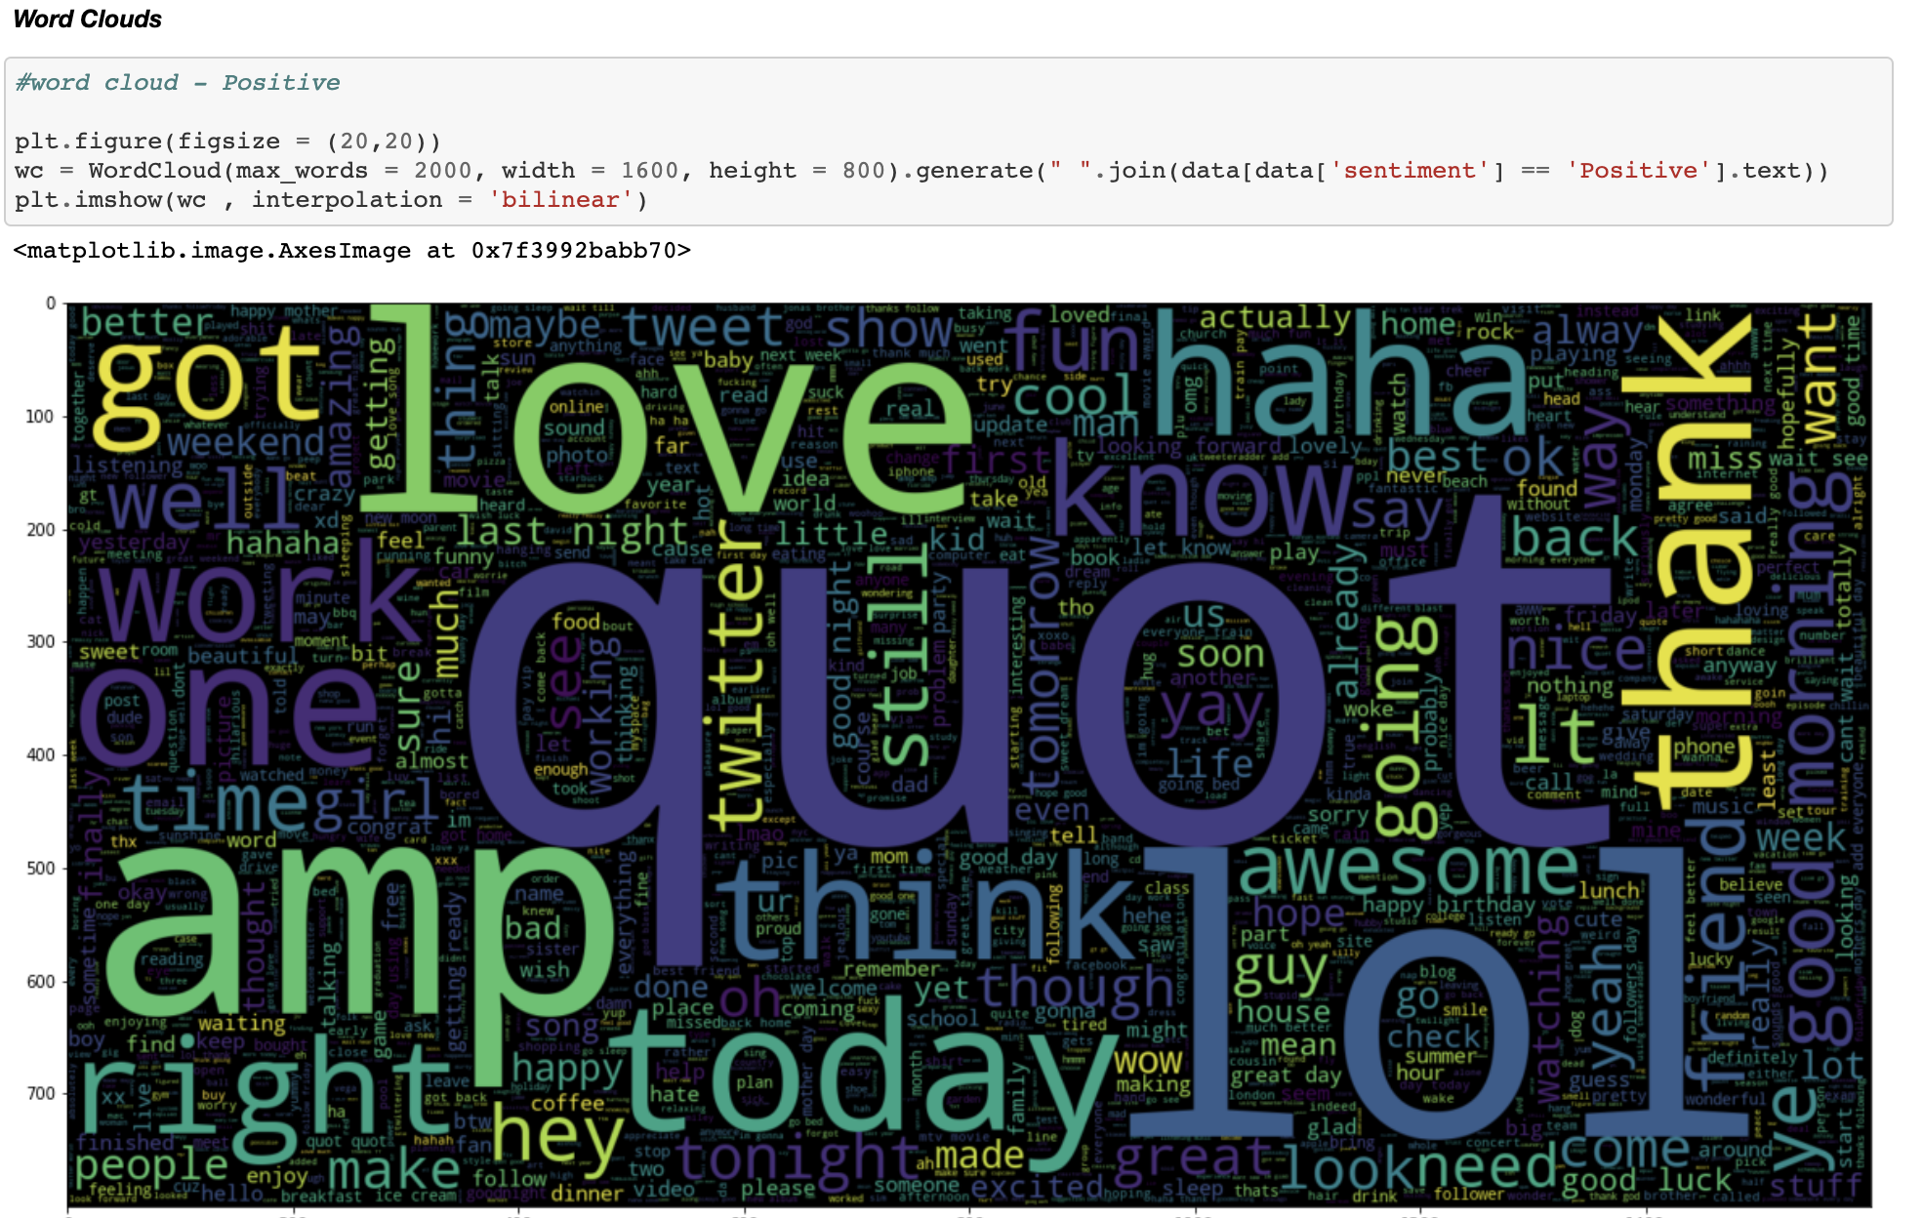

Negative Word Cloud

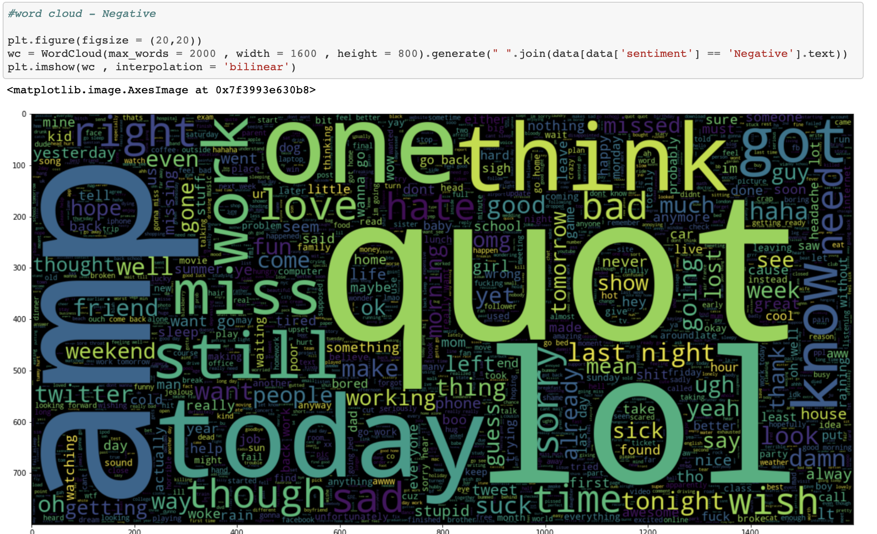

Test-Train Split:

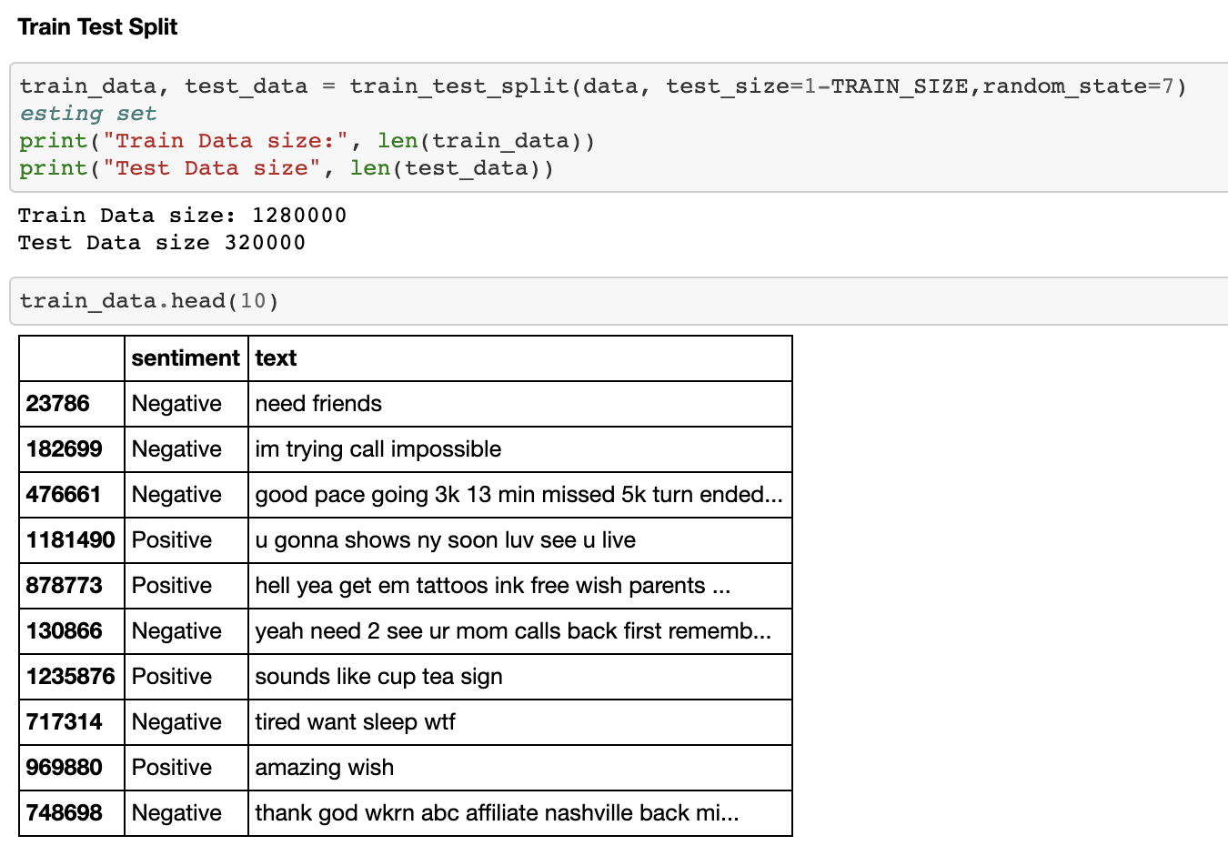

Tokenization: Over here we extract the word index for the corresponding words in the document

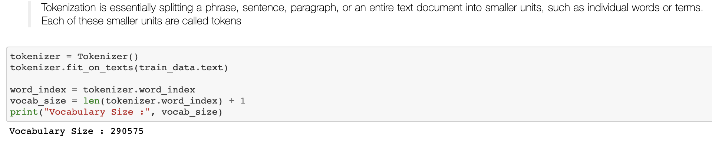

Pad Sequence: This is done in order to build a sequence model with a standard input shape

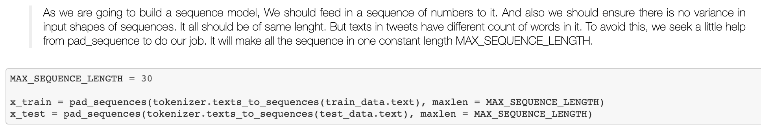

Shape before padding: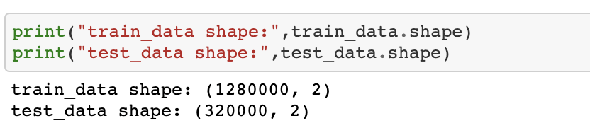

Shape after padding:

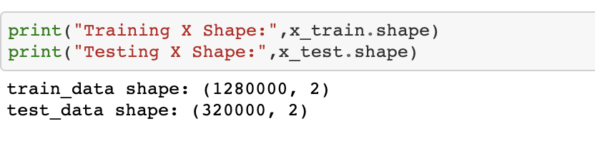

Label Encoder:

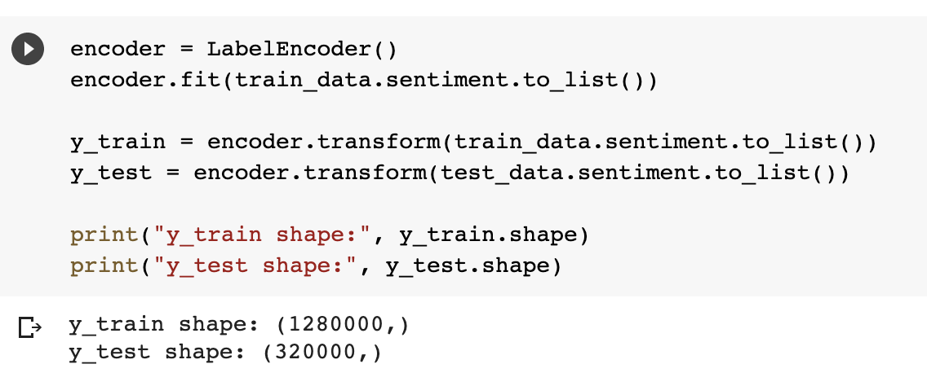

Reshaping:

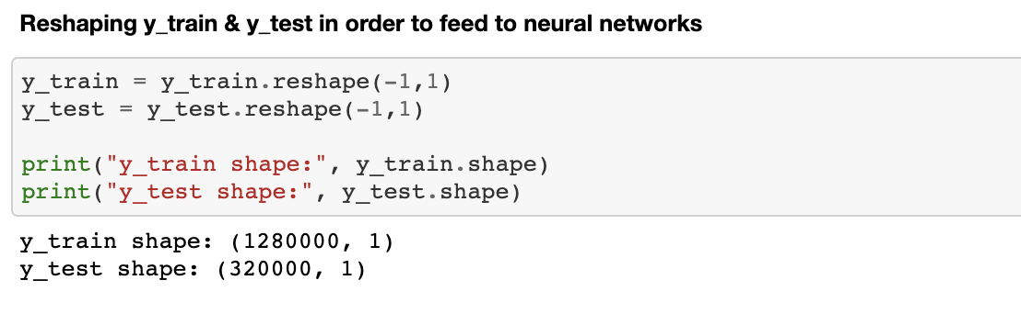

Word Embedding: There are 2 types – Glove & word2vec. We will be using Glove

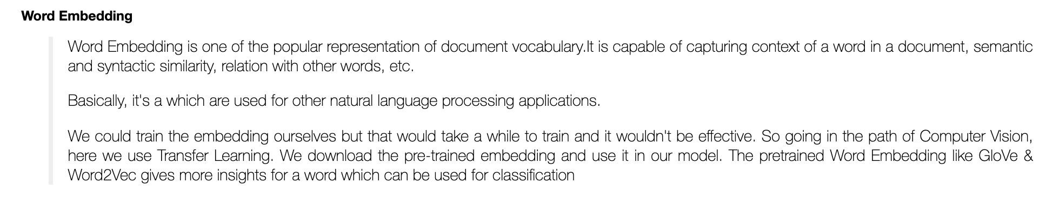

Downloading Glove Model:

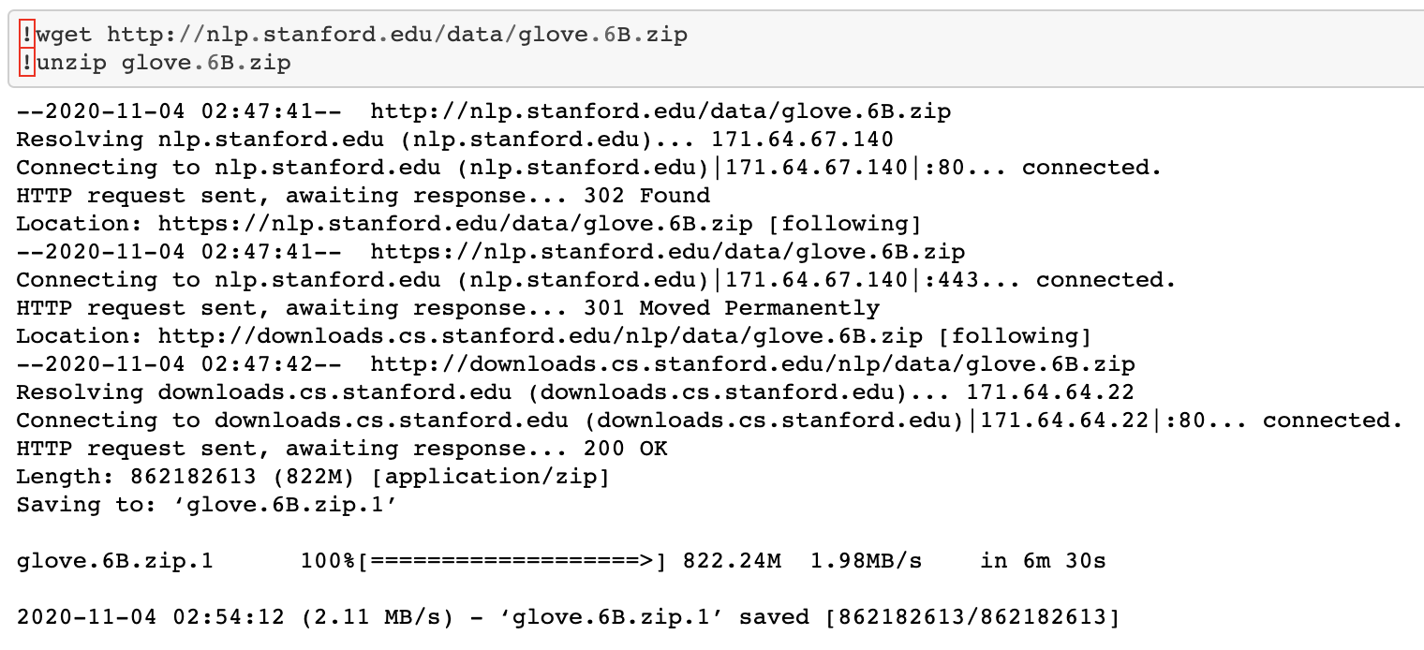

Extracting the words and their coefficients in glove model and store it to a variable called embedding_index:

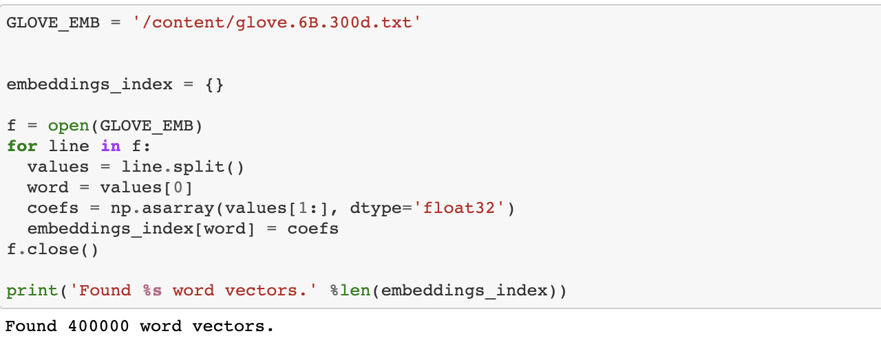

Printing the values extracted from glove:

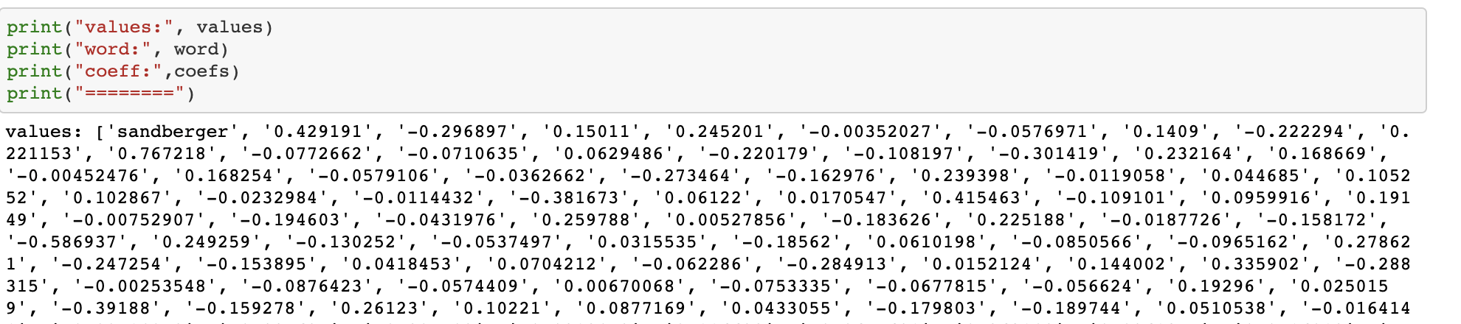

Looking at the coefficients of the word “the”:

